COURSE ROADMAP & SYLLABUS
Connected Device Security Assessment
Applying the Single Device Assessment Framework (SDAF) in BLE Security Assessments
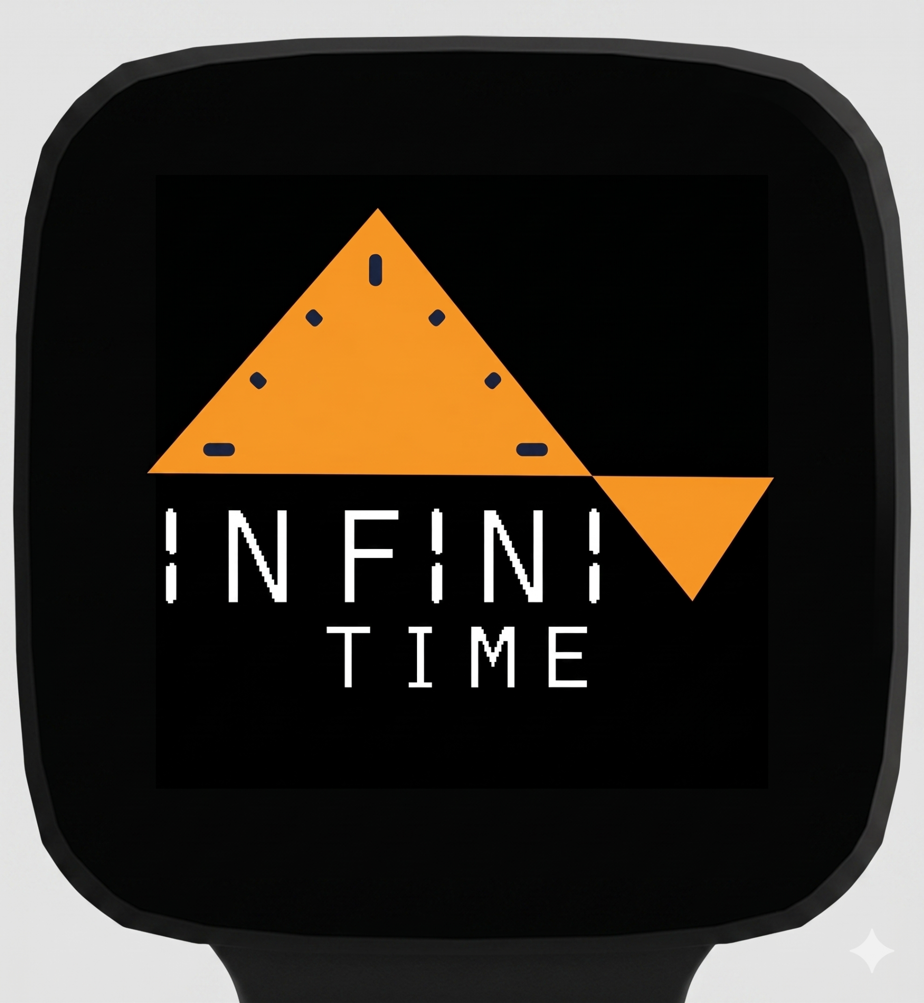
Course: ____________ Term: ____________

Format: lab-based · Prerequisite: basic C programming

Course Description
This teaches students to assess the security of connected embedded devices by applying the Single Device Assessment Framework (SDAF) to real firmware. Across six modules, students’ progress from building a correct Bluetooth Low Energy (BLE) application, to reading the embedded C/C++ that implements it, to analyzing the pairing and access control decisions that determine whether a device is secure, to classifying and scoring what they find. The InfiniTime smartwatch firmware serves as the worked example throughout.
Every module produces a deliverable rather than a worksheet. The work is the artifact. Modules 1–5 build discrete skills, Module 6 is the dry run using Infinitime. The Capstone is an independent, full SDAF assessment of an open-source BLE device the student selects. Using a fresh target makes the analysis the student's own work.
Scope. This is a source-based reading course. All analysis is done by reading source, with no compiling or device flashing required. Binary and firmware reverse engineering is a natural follow-on but is out of scope here. It belongs to a separate reverse engineering course (see “Beyond this course”).

Course Learning Outcomes
By the end of the course, students will be able to:
- Explain the BLE protocol stack and GATT model, and build a working, secured BLE peripheral.
- Read embedded C/C++ that defines GATT services and GAP/pairing policy, and locate the security relevant decisions within it.
- Distinguish security controls that are requested from those that are actually enforced, and recognize missing authentication and downgrade patterns.
- Classify findings with the correct CWE, and produce defensible CVSS 3.1 vectors and MITRE ATT&CK mappings.
- Conduct a structured, source-based static analysis assessment and produce a clear, evidence grounded report.
- Apply professional rules of engagement, including coordinated vulnerability disclosure.

Course Schedule
Each stage hands the next a concrete skill, so the capstone introduces no new material it is builds on everything before it.

SOURCE-BASED BLE ASSESSMENT
M1–M2  BLE + source | → | M3  security + pairing | → | M4  attacker's view | → | M5  classify & score | → | M6/Capstone  Infinitime + open source BLE SDAF
Classification & scoring (Module 5) is exposed through in module 3 – 4. Module 6 is the assessment on the InfiniTime firmware to serve as a warmup for the Capstone

Module Matrix (Source Based Assessment)
Each unit lists the skill taught, the deliverable, the InfiniTime finding it prepares students for, how it contributes to CVSS, and the primary resource.
Unit | Skill taught | Hands-on deliverable | Prepares for | CVSS Vector | Primary resource
Module 1  BLE & GATT foundations | BLE stack (GAP/GATT/ATT/SMP), advertising & connection, services, characteristics, handles, permission flags. Build a correct peripheral. | Working BLE peripheral plus a short writeup of its GATT table. | Reading InfiniTime's service files. | Introduce the idea of a security requirement per characteristic. | Nordic DevAcademy BLE Fundamentals (L1–4); NordicDeveloperAcademy/bt-fund
Module 2  Reading GATT in source | How a characteristic definition and its flags field look in C/C++. The GAP event handler (switch) pattern. | Annotated source map of a clean service: each characteristic, its flags, and the link security it requires. | Recognizing flag patterns in InfiniTime. | Label each characteristic with the access it should require. | Zephyr / Apache NimBLE peripheral samples. The Nordic LBS from M1.
Module 3  BLE security & pairing | Pairing vs bonding, legacy vs LE Secure Connections, the I/O-capability matrix, Just Works downgrade, requested vs enforced MITM. | Before/after nRF Sniffer capture: an unsecured characteristic vs the same one over a paired, encrypted link. | Just Works downgrade, silent bond replacement. | Score the unsecured baseline students' first full CVSS vector. | Nordic DevAcademy Lesson 5, BLE Security Fundamentals.
Module 4  The attacker's view | GATT enumeration, unauthenticated read/write, decoding characteristic values. | Flag log plus notes on which characteristics were reachable with no authentication. | The 'unpaired peer reaches everything' trap. | Write a CVSS vector for each reachable characteristic. | hackgnar/ble_ctf (+ ble_ctf_infinity).
Module 5  Classification & scoring | CWE taxonomy, CVSS 3.1 vectors metric by metric, MITRE ATT&CK basics, OWASP IoT Top 10 as a checklist. | Scoring worksheet: three behaviors mapped to CWE + CVSS vector + ATT&CK technique, then peer compared. | The report's CWE/CVSS/ATT&CK content. The rubric's severity justification criterion. | This module is the ‘bowtie’. | MITRE CWE; FIRST.org CVSS calculator; MITRE ATT&CK; OWASP IoT Top 10.
Module 6  Capstone — BLE SDAF | Synthesis: a full, independent SDAF assessment of an open-source BLE device the student selects (not InfiniTime). | Complete SDAF report: ≥3 findings, CVSS vectors, an ATT&CK chain, prioritized remediation. | Going into the wild independent assessment work under disclosure. | Severity justification graded directly against the rubric. | A student chosen open-source BLE repo. The capstone assignment handout.

The CVSS Scoring
Classification and scoring is both a module and a habit. Module 5 teaches it formally, but from Module 3 onward every deliverable carries a small scoring step, a CVSS vector here, a CWE there, so that by the capstone, producing a defensible vector is reinforced rather than something attempted for the first time under exam pressure.

Suggested Assessment Structure
Weights are a starting point. The intent is to reward the portfolio of module deliverables and the Module 6 capstone roughly equally.
Component | Weight | Form
Module deliverables (M1–M6 lab portfolio) | 35% | 5 artifacts
Scoring quality (assessed across deliverables) | 15% | Continuous
Capstone: independent BLE SDAF assessment | 45% | Report
Participation / lab engagement | 5% | Continuous

Resources & Tooling

Courses & practice targets
- Nordic Developer Academy Bluetooth Low Energy Fundamentals (free, hands-on; Lesson 5 covers security & the nRF Sniffer). Exercises: NordicDeveloperAcademy/bt-fund.
- hackgnar/ble_ctf and hackgnar/ble_ctf_infinity ESP32 BLE capture-the-flag for GATT enumeration and unauthenticated access.
- Practical IoT Hacking (Chantzis et al.), whose BLE chapter is built around ble_ctf.

Reference frameworks
- MITRE CWE
- FIRST.org CVSS 3.1 calculator
- MITRE ATT&CK
- OWASP IoT Top 10.

Tools
- nRF Connect (mobile & desktop), the bleak Python library, BlueZ (bluetoothctl / gatttool), Wireshark with the nRF Sniffer.

Hardware
An nRF52840 DK (~$50) and a pair of ESP32 boards (~$10 each) for ble_ctf, plus a BLE sniffer dongle.

Beyond this course
This practicum is deliberately scoped to source-based BLE assessment. Two natural extensions sit just past its boundary:
- Binary & firmware reverse engineering. Recovering the same security configuration from a compiled image in Ghidra looking at what survives optimization and stripping, and how to find it without reading raw assembly. This is a course in its own right and is best taught as a separate follow on, with its own standardized deliverable, after students are fluent reading the source.
- Live assessment. Selecting a consumer device, conducting a full SDAF assessment on owned hardware, and if a vulnerability is found, practicing coordinated disclosure end to end.

